High Level Design (HLD)

Automatic Number Plate Detection and Recognition (ANPR)

Revision Number: 1.0

Last Revision Date: 17/01/2023

# Document Version Control

|  |  |  |  |
| --- | --- | --- | --- |
| Date Issued | Version | Description | Author |
| 17/01/2023 | 1.0 | Final | Yatrik Shah |
|  |  |  |  |
|  |  |  |  |

Contents

I. Document Version Control 2

II. Abstract 4

1. Introduction 5

1.1 What is High Level Design Document (HLD) 5

1.2 Scope 5

1.3 Definitions 6

2. General Description 7

2.1 Product Perspective 7

2.2 Problem Statement 7

2.3 Technical Requirements 8

2.4 Data Requirements 8

3. Design Details 9

3.1 Process flow 10

3.2 Event Logs 10

3.3 Error Handling 10

4. Performance 11

4.1 Reusability 12

4.2 Application compatibility 12

4.3 Deployment 12

4.4 User Interface 13

# Abstract

Computer vision is a field of study focused on the problem of helping computers to see. At an abstract level, the goal of computer vision problems is to use the observed image data to infer something about the world.

In huge systems of vehicle control like traffic management on highways or traffic management in big events and at highway tolls gathering information of the vehicles which were involved, by their number plates manually is very difficult so, AI can solve this problem using advanced computer vision algorithms.

Automatic Number Plate Detection and recognition is a technology that uses optical character recognition on images to read vehicle registration plates / number plates.

# Introduction

## What is High Level Design Document (HLD)

The purpose of this High-level document (HLD) is to describe the design of the

project in detail which can be used as a reference manual.

The HLD will:

• Present all the design aspects and define them in detail.

• Describe the user interface being implemented.

• Describe the software interfaces.

• Describe the performance requirements.

• Include design features and the architecture of the project.

## Scope

The HLD document present the entire structure of the project in parts, such as the data ingestion, data pre-processing, solution development and the deployment part along with their respective architectures. This uses non-technical to mild technical terms which should be understandable to the administrators of the system.

## Definitions

**Image Resizing**- Resizing allows you to make your image smaller or larger without cutting anything out. Resizing alters the image's dimensions, which typically affects the file size and image quality. The most common reason for resizing photos is to reduce the size of large files to make them easier to email or share online.

**Convolutional Neural Network-** Within Deep Learning, a Convolutional Neural Network or CNN is a type of artificial neural network, which is widely used for image/object recognition and classification. Deep Learning thus recognizes objects in an image by using a CNN.

**Image Dimensions-** Image dimension refers to the width and height of an image, measured in pixels.

**YOLO-** You Only Look Once

# General Description

## Product Perspective

The Concrete compressive Strength Predictor is basically a Machine Learning based regression model which can predict compressive strength of concrete from all the materials used to make the concrete, some of those are: cement, water, Coarse Aggregate, Fine Aggregate, fly ash.

## Problem Statement

As manually number plate data collection and maintenance is very challenging and can be very time consuming task, it may not be possible to perform it on millions of vehicles.

So as a solution, we can automate it using deep learning and computer vision.

## Technical Requirements

Software:

python = 3.10.4

numpy

panda

tensorflow > 2.0

opencv-python = 4.5.4

torch = 1.13.0 + cpu

matplotlib

easyocr = 1.6.2

pytesseract = 0.3.10

flask = 2.1.3

flask_cors = 3.0.10

HTML5 + CSS

Hardware:

A device with normal CPU and 2+ GB ram

## Data Requirements

Here the dataset is containing two directories. Out of which one is containing images, and another is containing annotations of the respective images.

Here the word Annotations refers to the details of the bounding box of the object that is present in the image like: class, bounding box coordinates i.e., x minimum, x maximum, y minimum, y maximum.

The images in the data can be in different shapes. So, they are reshaped in the dimensions (640 * 640 * 3). And the Annotations are also scaled respectively.

Images are in different file formats like: .jpg, .jpeg, .png. And Annotations are stored in Extensible Markup Language (.xml).

The dataset is collected from [Kaggle](https://www.kaggle.com/datasets/andrewmvd/car-plate-detection). As well as some numbers of images are also collected manually. And also, the respective Annotations including the bounding box, in order to get some real-life images which basically contains noise.

The main goal to perform this step is to add some more noise in data and create more generalized and robust model.

# Design Details

## 3.1 Process flow

* Data Collection
* Preprocessing
  + Resizing
  + Rescaling
* Model Building
  + Custom CNN Model from scratch
  + YOLOv5
* Model Training
* Database
* Building Frontend with HTML CSS
* API with Flask
* Deployment

## Event Logs

Logging is the very essential part of end-to-end systems. By the logs we can make sure what is going on internally and if system crashed then why was it crashed.

Here logging used in every part of the project so the prefect scene can be imagined that what is the exact flow of the program is!

## Error Handling

Here in every module the exception handling is done, so that it does not cause system failure or system error.

In case of any warnings or error occurred, it would be noted in the logs.

# Performance

Performance of Number Plate Detection Model:

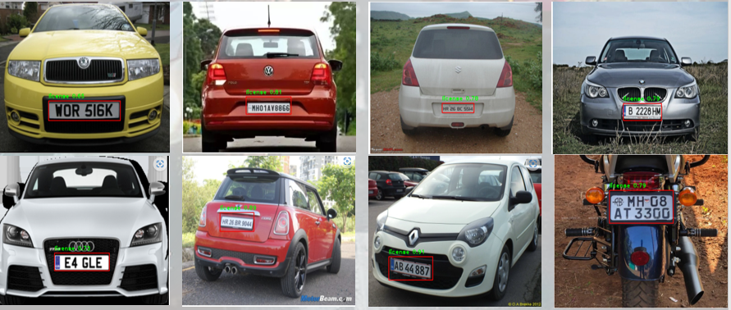

* Application Working

## Reusability

The code written and the components used have an ability to be reused

without any problem.

## Application compatibility

The different components or modules of this project use python as their interface between them. Each component has its own task to perform, and it is the job of the python version to ensure proper transfer of the information.

## Deployment

Here Neurolab is taken as the Deployment Platform

Neurolab is platform provided by company “iNeuron”.

It provides Development and deployment platform.

Ultimately it provides a “PULBIC URL” of the project work Automatic Number Plate Detection.

So, anyone in this world publicly use that PULBIC URL and can make their life easy.

## User Interface

